Gear Heat Treatment
Special heat treatment design is carried out according to the different needs of specific industries for gears, mainly including induction single-tooth quenching and induction-type integral tooth quenching. Single tooth quenching is divided into tooth surface quenching and tooth surface and root quenching. After quenching, tempering treatment is carried out to make the surface hardness and the depth of the hardened layer meet the design standards. The most advantageous process is the special process of integral tooth quenching, which can improve the transmission efficiency and increase the wear resistance and impact resistance of the tooth surface, so as to meet the needs of customers.

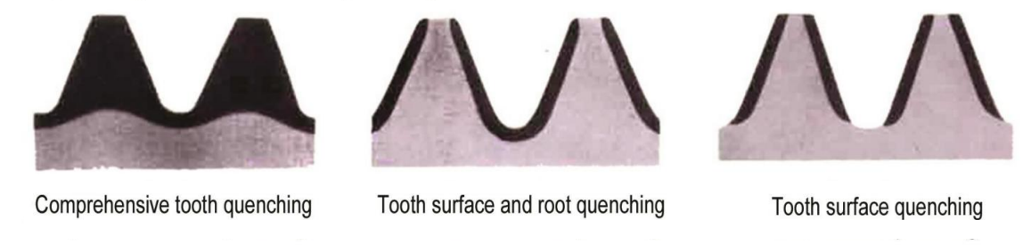
The raceway heat treatment of the slewing bearing is realized by induction heat treatment technology. Xuzhou Wanda Slewing Bearing has advanced heat treatment equipment (processing equipment and testing equipment) and scientific processing technology, so that the depth and hardness of the hardened layer conform to JB /T2300-2018 slewing bearing standard.
